ADVANCED WEB DESIGN AND DEVELOPMENT
PRACTICAL LOGBOOK

Name | Maryan Ahmed
Admission no. | BSCCS/2024/61542
Course | Computer Science
Unit Code | BIT3208
Unit Name | Advanced Web Design and Development
Lecturer Name | Michael Nyoro
Sem/Year | Year 3 Sem 2

Project Title:
RentVille – Tenant Management System
Technologies: PHP + MySQL | HTML | CSS
GitHub Link: https://github.com/maryan54/RentVille.git
Contents
WEEK 1 : LOCAL ENVIRONMENT SETUP 3
Week 2: Wireframes and GUI Design 6

WEEK 1 : LOCAL ENVIRONMENT SETUP

Title : Installation and Testing of Local Development Environment
Required evidence

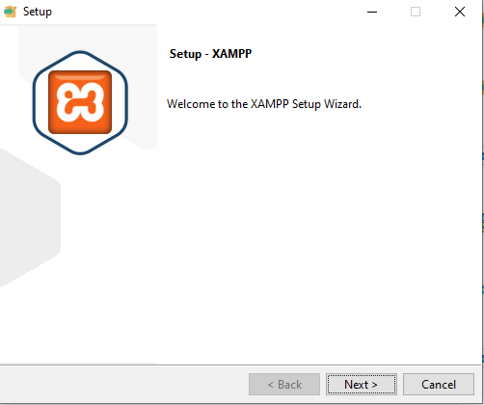
Figure 1: Installation of XAMPP

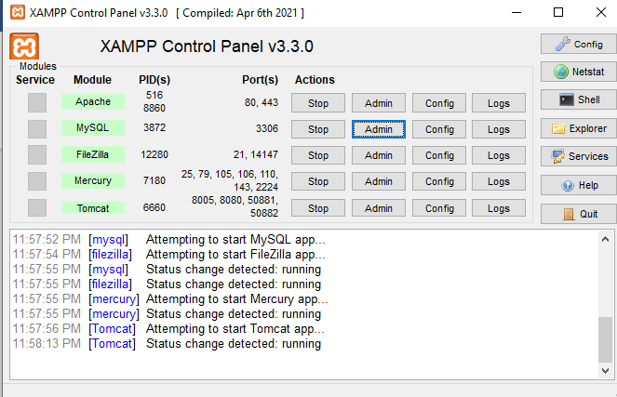
Figure 2: Apache and MySQL running in XAMPP

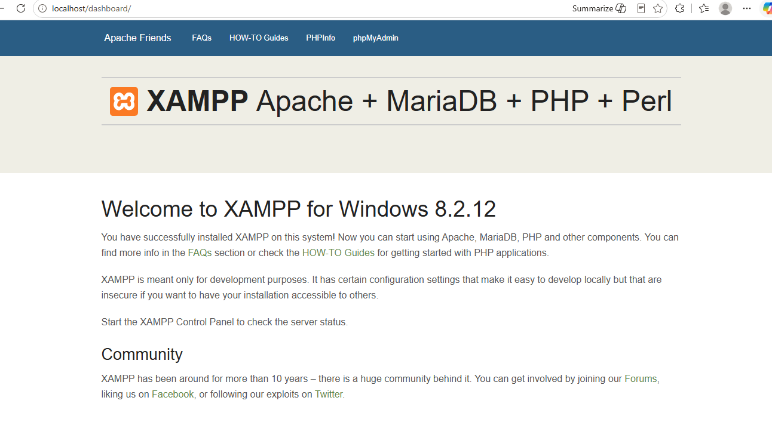
Figure 3: Localhost Running in the browser
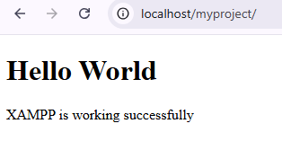
Figure 4: Hello world test page running

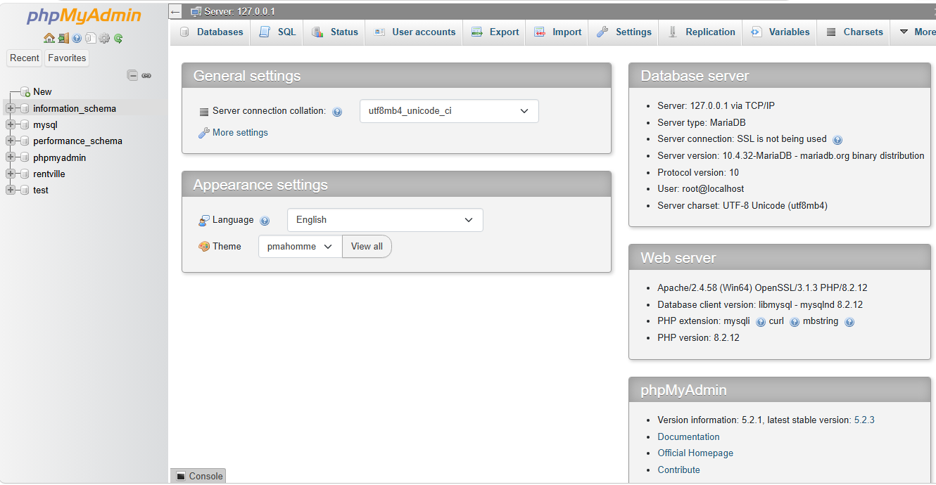
Figure 5: Database connected successfully

Student Reflection
During Week 1, I installed XAMPP and configured Apache and MySQL on my local machine.. Both Apache and MySQL services are running. I have ensured that the localhost environment is fully functional. I have created my first Hello World PHP page where it assured mys successful connection to the web. I have been able to successfully established PHP-to-MySQL connection using PDO.

WEEK 2 : WIREFRAMES AND GUI DESIGN

Title : User Interface Planning and System Design
Required evidence

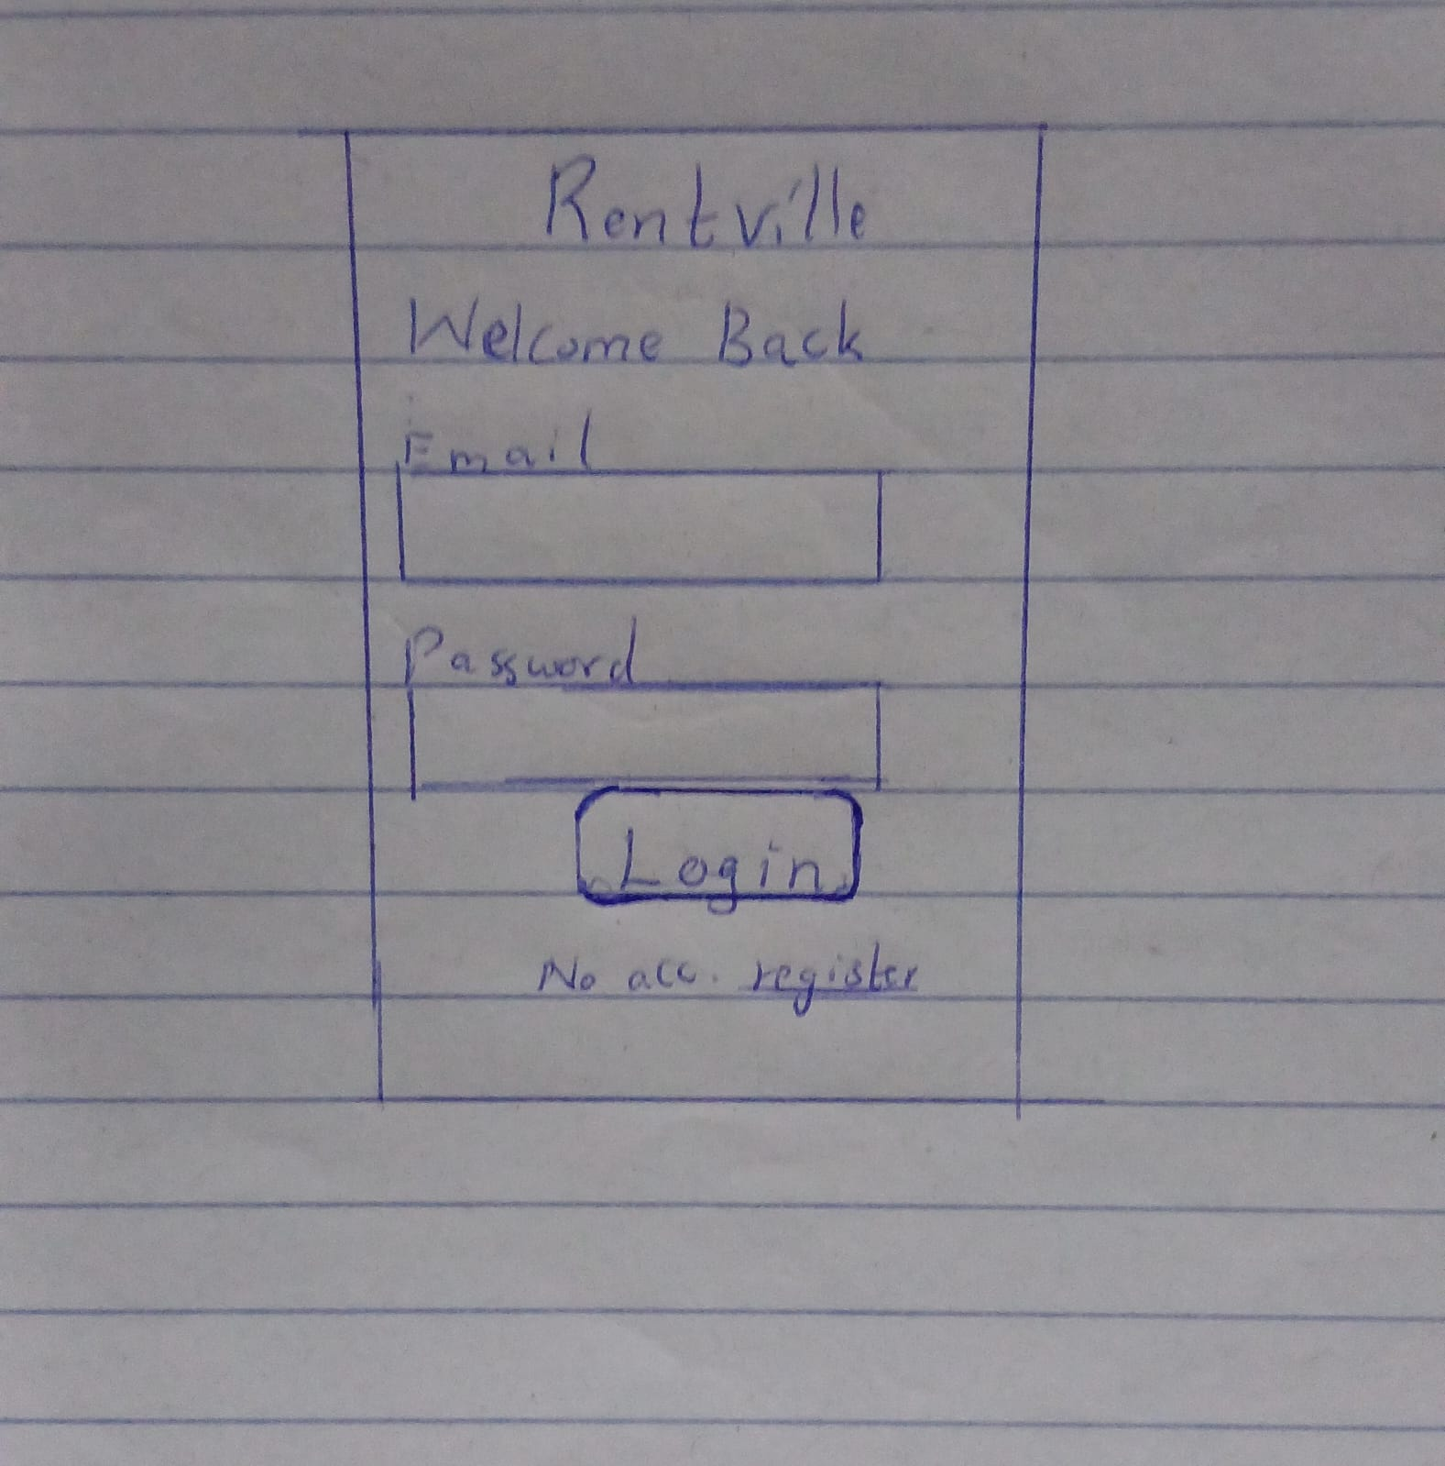
Figure 6: Hand-drawn Wireframe of the Login page
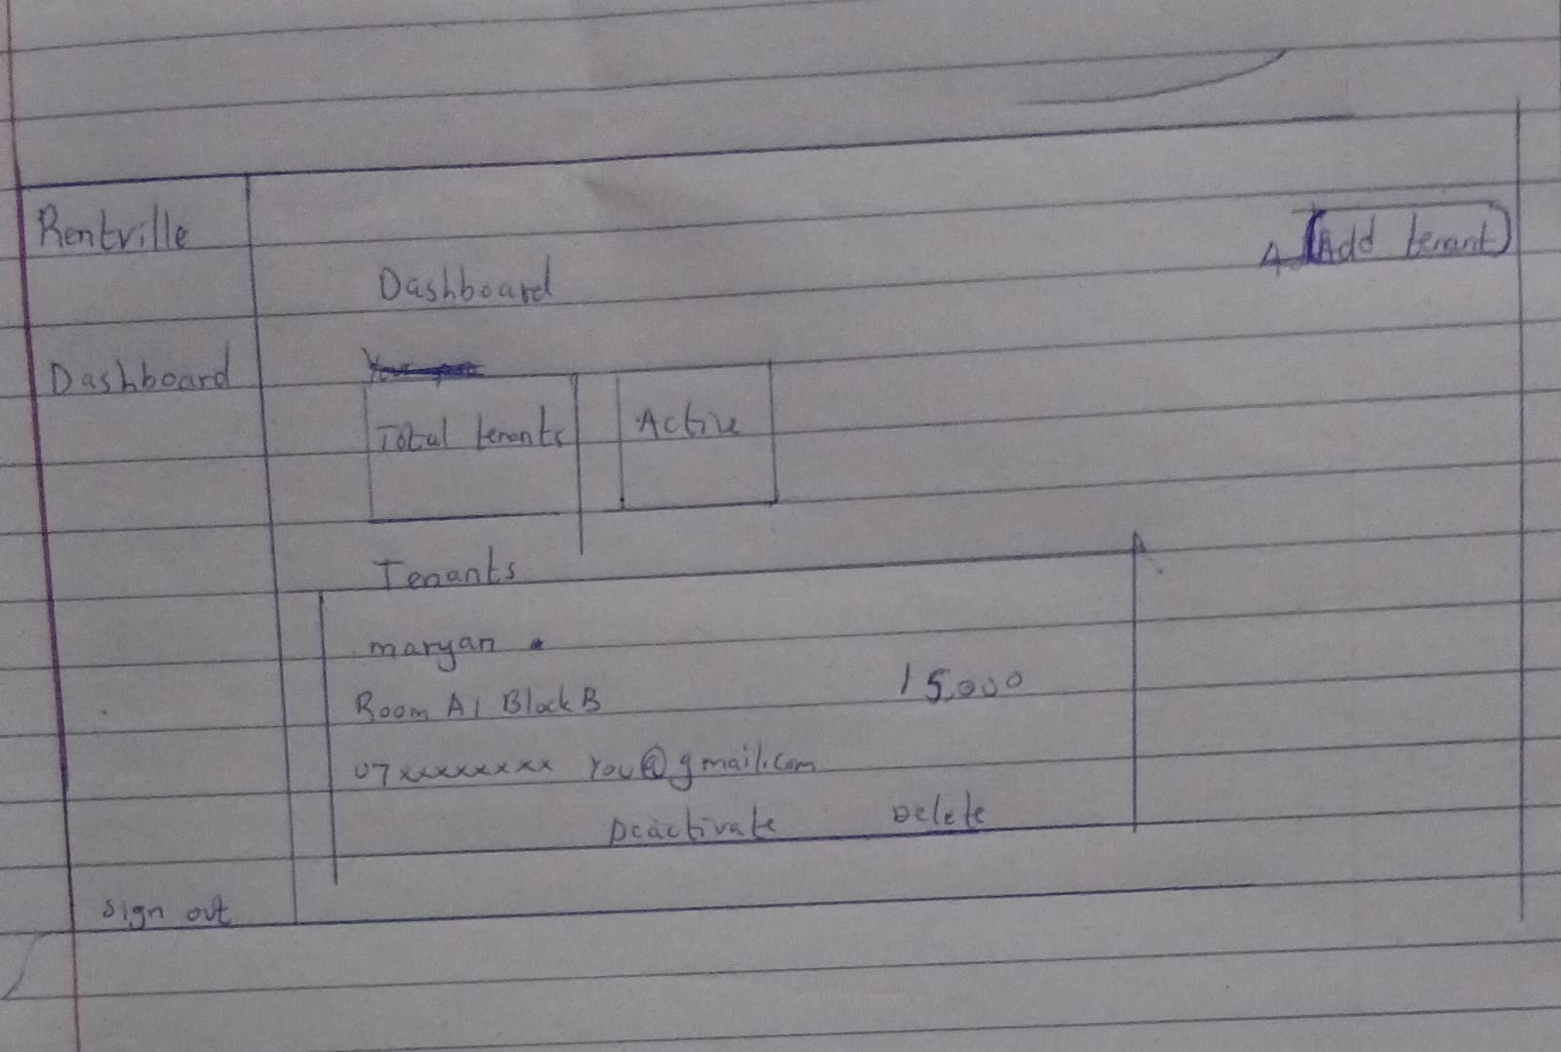
Figure 7: Dashboard layout design wireframe
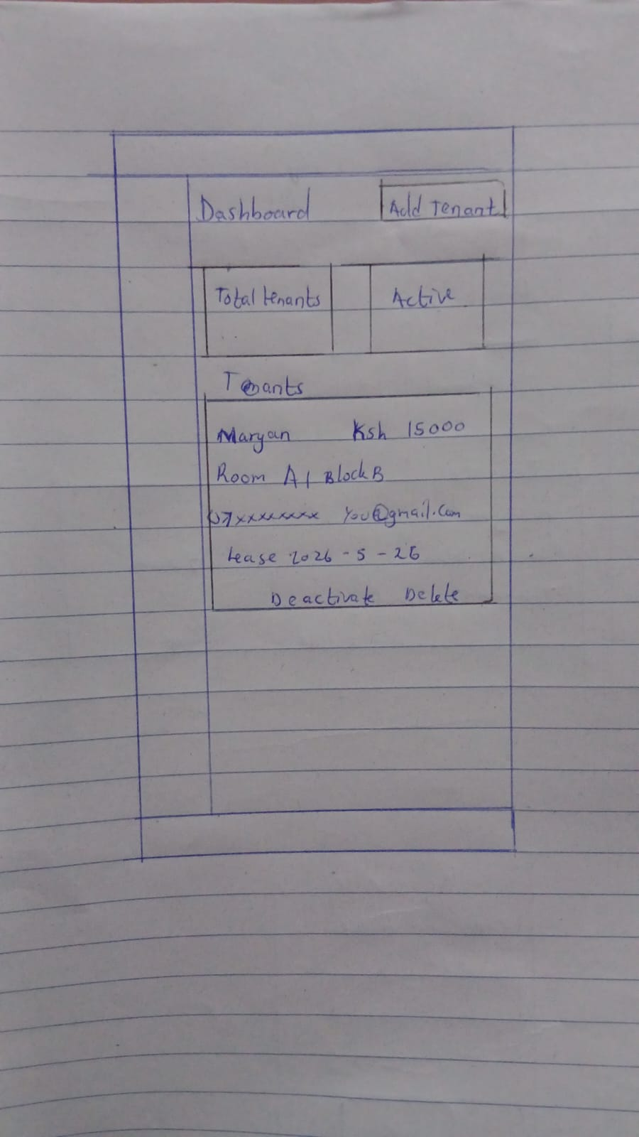
Figure 8: Mobile view mockup Wireframe
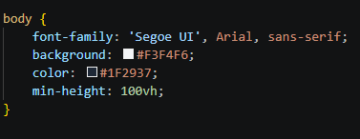
Figure 9:Chosen Colour format

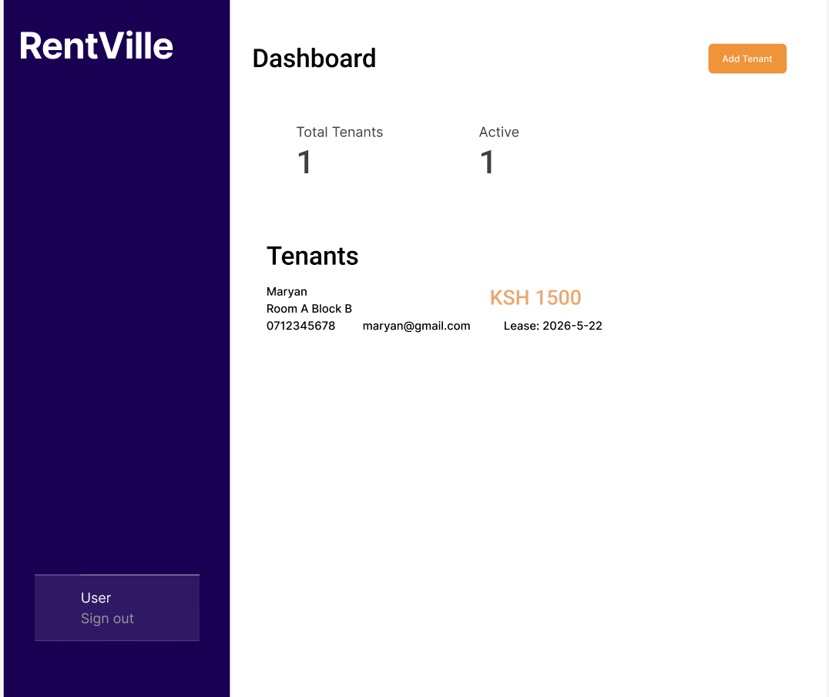
Figure 10:A figma model of the dashboard

Student Reflection
This week I focus on Interface planning and system design. I made hand drawn wireframes of the login, dashboard and mobile mockup of the page. The dashboard was designed to reduce user clicks and improve accessibility and navigation bar on the left for scalability.I finally digitized the GUI on figma to create a prototype providing a soli blueprint.

WEEK 3 : Javascript and PHP Basics

Title : Frontend interactions and backend foundation
Required evidence
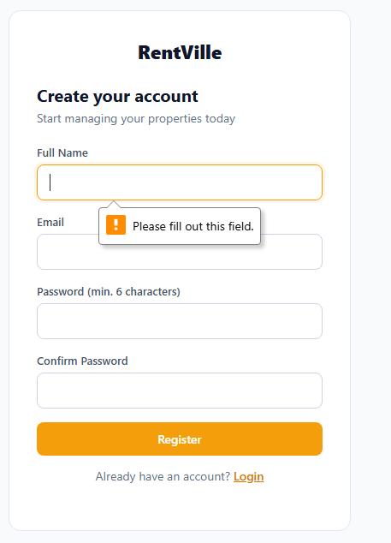
Figure 11: Form validation preventing submission of empty forms
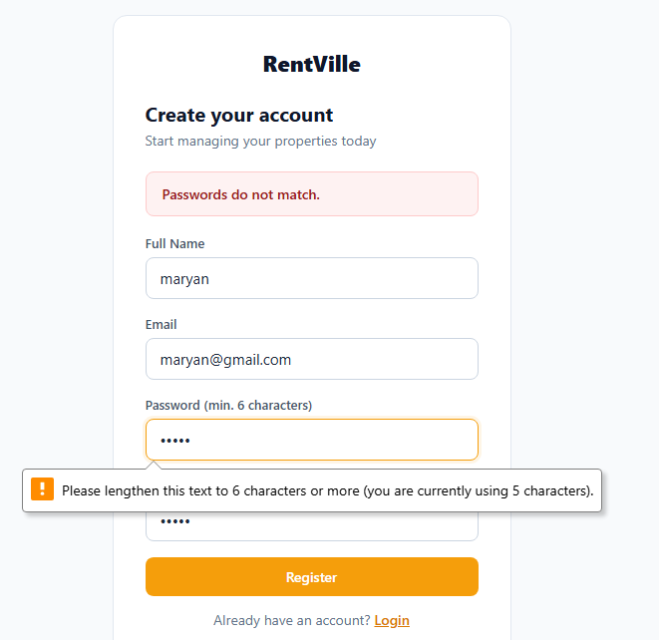
Figure 12: Password has to be a length of 6 characters and above

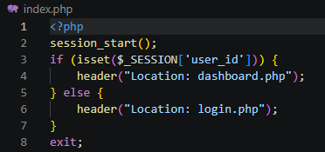
Figure 13: PHP syntax Practice with if conditional statement

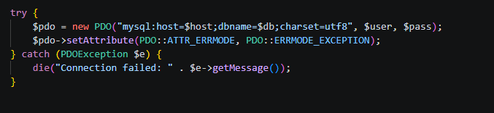
Figure 14: Database Connection Script Usin PDO

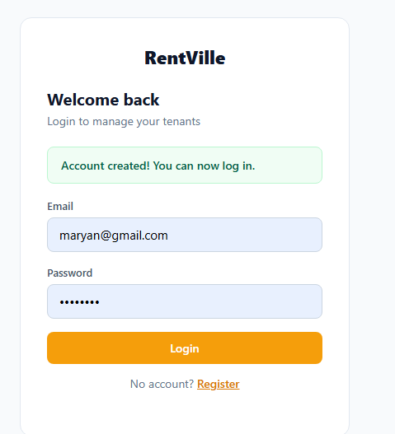
Figure 15: Dynamic User Input Handling

Student Reflection
This week I bridged the frontend and backend layers of RentVille.I explored data validation that prevents users from submitting blank login fields, improving UX before data reaches the server. I larn and implemented the password strength checker used on the register page. I looked at core PHP concepts including conditionals, loops and variables. The db.php file shows the PDO connection to MySQL with error handling. Lastly I explored dynamic output from PHP based on submitted form data.

WEEK 4 : Server-Side Components and Backend Development

Title : Backend Form Processing, Authentication and Project Structure
Required evidence
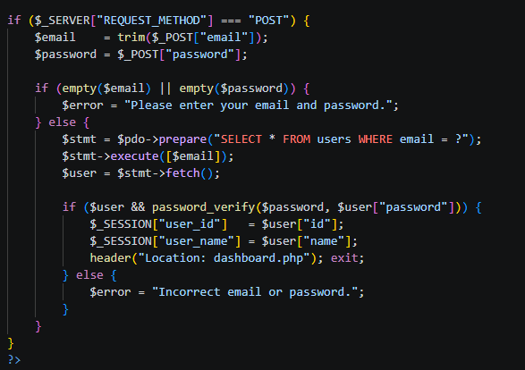
Figure 16: Login form wih POST method

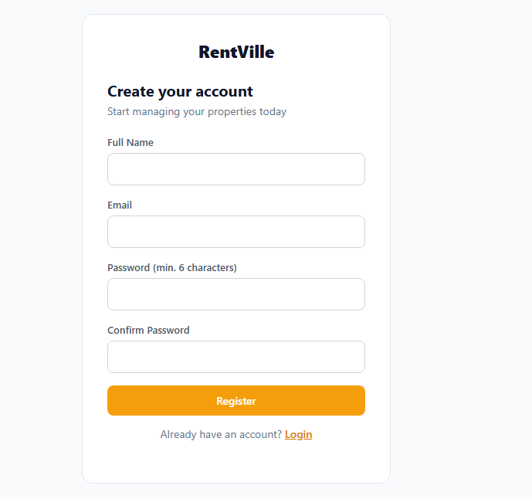
Figure 17: Registration form


Figure 18: PHP session-based-athentication that redirects to dashoboard after login

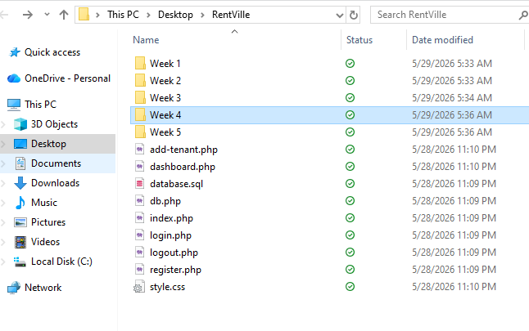
Figure 19: Project folder structure per week

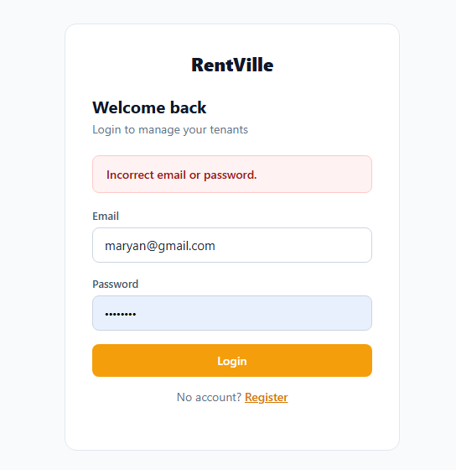
Figure 20: Denying access when wrong credentials are used

Student Reflection
Week 4 brought the backend of RentVille to life. First I created the login form sending data via POST and the registration form with password confirmation. We are able to confirm that PHP sessions correctly redirect authenticated users to the dashboard. The files are stored in a clean project folder structure in weekly form. This came out as a successful loginand an organized pile

WEEK 5 : Database compenents and CRUD Operations

Title : Building a Data-Driven Tenant Management System
Required evidence

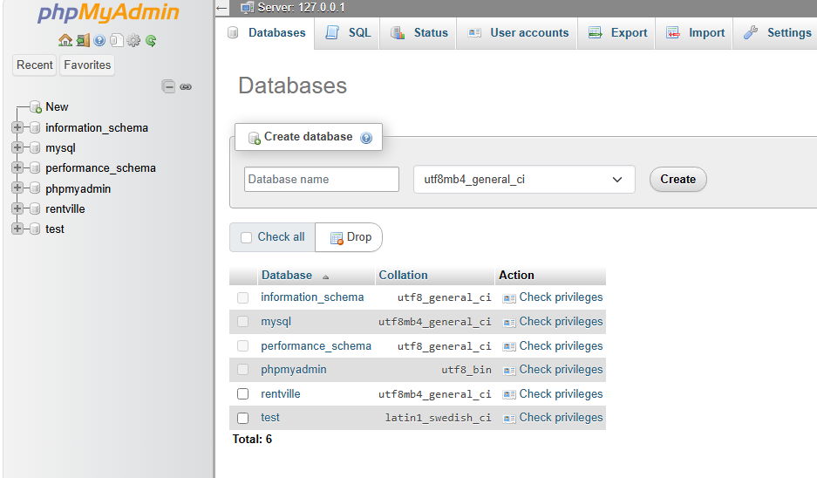
Figure 21: Database created and visible in phpMyAdmin

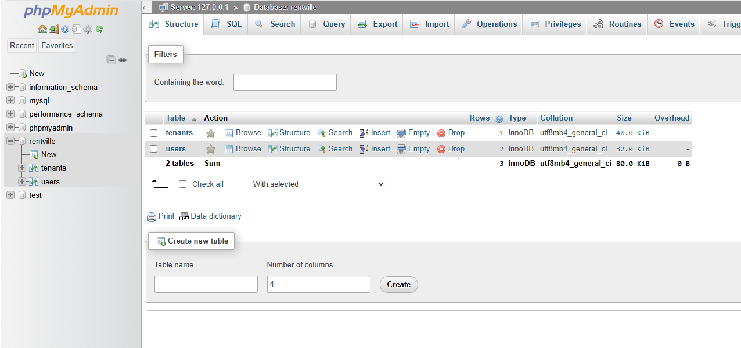
Figure 22: Tables Successfully created on phpMyAdmin

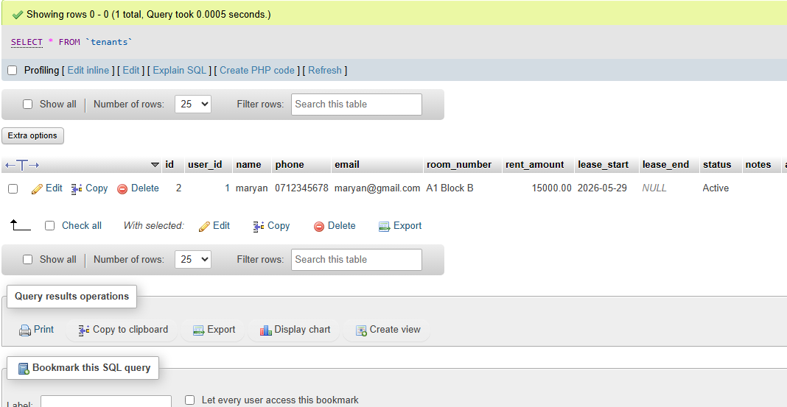
Figure 23:Tenant Records successfully added to the table

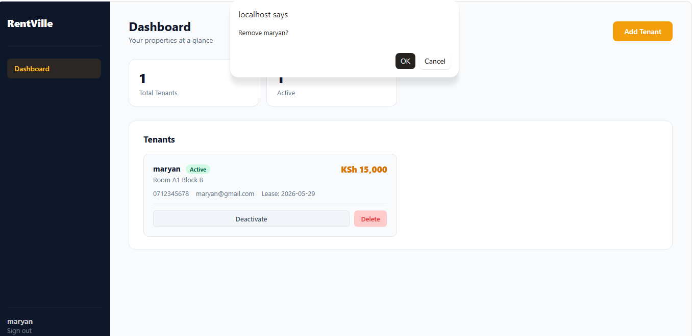
Figure 24: Notification to use the DELETE operaion

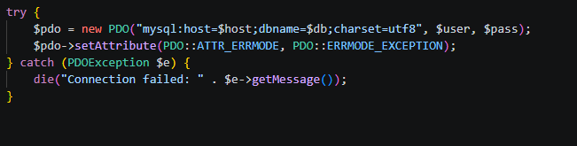
Figure 25: Db connected via the PDO

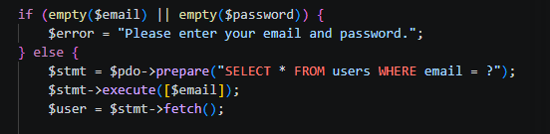
Figure 26: Pulling user data from Database for validation

Student Reflection
Week 5 completed the core functionality of RentVille with the backend. I used SQL to create the database and tables. I confirmed the tables exist in phpMyAdmin and shows the Add Tenant form which inserts records into MySQL. I ensured that the dashboard is fetching and displaying all tenants dynamically. At last the last task demonstrates the toggle and delete actions completing the full CRUD cycle.

